10.60: In Fig. (10.22) and Eq. (10.22), with the angle measured from the vertical, 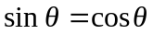 in Eq. (10.2). The torque is then 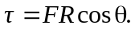

- 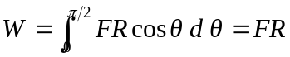
- In Eq. (6.14), dl is the horizontal distance the point moves, and so 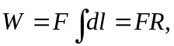 the same as part (a). c) From 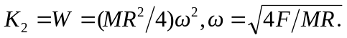 d) The torque, and hence the angular acceleration, is greatest when 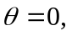at which point 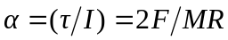, and so the maximum tangential acceleration is 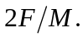 e) Using the value for found in part (c), 